Barns Medical Practice
Service Specification Outline:

The Diagnosis and Management of Chronic Obstructive Pulmonary Disease

Up-dated: November 2019 Review Date: January 2021

Introduction

Chronic Obstructive Pulmonary Disease (COPD) is characterised by airflow obstruction that is not fully reversible. It is progressive and predominantly caused by smoking. The damage results in chronic inflammation that differs from asthma. The object of correct management of COPD is to reduce mortality, reduce exacerbations and cut down hospital admissions. It also hopes to achieve optimum health benefits.

Symptoms tend to be breathlessness on exertion, chronic cough, regular sputum production, frequent winter bronchitis and wheeze. Consideration should also be given to those complaining of fatigue, effort intolerance, weight loss, ankle swelling, chest pain and haemoptysis (coughing up blood).

Diagnosis

The diagnosis should be based on signs and symptoms, history taking and supported by a breathing test called ‘spirometry and reversibility’. Patients are generally over 35, smokers and with one or more of the above symptoms.

The MRC 1-5 dyspnoea score is recorded to ascertain the degree of breathlessness incurred and the CAT (COPD Assessment Test) score helps the clinician to decide the best treatment for the individual patient.
If spirometry results show a FEV1 (forced expiratory volume) less than 80% predicted and FEV1/FVC is less than 0.7 or 70% a diagnosis can be confirmed. If FEV1 is greater than 80%refer back to GP for differential diagnosis.

Global Initiative for Chronic Obstructive Lung Disease. Global strategy for Diagnosis, Management and Prevention of Chronic Obstructive Pulmonary disease. Report 2020. Available online at http://www.goldcopd.org [Accessed 15/05/2020].

The diagnostic code for COPD #h3z should be coded priority 1 and a Problem created.

Annual Review

- A 20 minute appointment should be offered with the practice nurse
and the COPD template within the consultation manager completed.
- MRC score should be recorded as well as, Pulse oximetry, CAT score and FEV1.
(Consider referral to respiratory if SA02 is less than 93%).
- Check inspiratory flow with in-check dial – DPI 30-90l/min; MDI 30-
60l/min
- Smoking status recorded and cessation advice given
- Inhaler technique observed /taught. Spacer devices are compatible
with MDI (metered dose inhalers) and inhaled drugs can be
administered via a spacer by single inhalation or tidal breathing.
- Spacers should be washed at least monthly and replaced annually.
- COPD reviews should be tailored to meet the needs of the individual patient where goal planning is discussed to identify health needs, reduce exacerbations and maximise health.
- The importance of exercise, nutrition, advanced care planning and telehealth should be discussed.
- Vaccinations for Pneumococcal and Flu should be offered.
- Self management plans should be discussed and medication in
reserve organised if deemed appropriate. Thereafter an anticipatory care plan should be completed.
- If the MRC score is greater than 3, a referral to pulmonary rehab
should be offered. A patient information sheet is available on Barnsnet and guidance for referral can be found on the athena website.

ADDENDUM: Due to the COVID-19 Pandemic, Annual Reviews have been postponed in most cases.

Treatment

- It is important that inhalers are prescribed only after patients have
received adequate training in the use of the device.
- For intermittent breathlessness and exercise limitation, offer short
acting bronchodilators (SABA) 1st choice is salbutamol MDI with or
without spacer. Second choice is Easyhaler Salbutamol.
- If symptoms persist add either long acting b2-agonist (LABA) 0r long acting muscarinic antagonist (LAMA).
- LABA: Formoterol Easyhaler OR Atimos Modulite MDI.
- LAMA: Spiriva Respimat OR Incruse Ellipta.
- If still having more significant symptoms and FEV1 > 50% and < 1
exacerbation in last 12 months not requiring hospital admission: stop LAMA or LABA and use combination LAMA/LABA
Anoro ellipta OR Spiolto Respimat.
- If continuing symptoms: consider a 3 month trial of SABA & LAMA/LABA/ICS (triple therapy). A significant portionof patients with COPD may not benefit from inhaled corticosteroids and it is important to observe effect. If no improvement, discontinue and continue LAMA/LABA.
- Consider other treatments such as theophylline if inhaled therapy is ineffective. Acetylcysteine could be considered with patients who have chronic cough and excessive sputum but should not be prescribed to prevent exacerbations in patients with stable COPD. The use of Acetylcysteine (avoid a/biotic 2hrs before or after use) should be reviewed after 4 weeks and if no benefit stop.
- Longterm Oxygen Therapy (LTOT) is indicated for patients with severe resting hypoxaemia. Referrals for LTOT should be made to the respiratory nurse specialists. Patients must be non-smoking and Sp02 ≤92% at rest; Sp02 ˂ 90% on exertion.
- Long-term treatment with daily oral steroids is not recommended, although short-term plays a role in managing exacerbations.
- It is recommended that the prescribing of Azithromycin is under the recommendations of a specialist respiratory physician. Azithromycin has been shown to reduce COPD exacerbations. A baseline ECG and LFTs should be checked before commencing.

http://athena/adtc/DTC%20%20Clinical%20Guidelines/ADTC64A.pdf

Resources

Information leaflets on COPD can be found on the internet and
patient.co.uk. Patients can be signposted to fresh-air-shire and local
pharmacies if they wish additional support with smoking.
http://www.nhsaaa.net/services-index/f-fresh-air-shire.aspx
http://www.nhs.uk/conditions/chronic-obstructivepulmonarydisease/
pages/introduction.aspx

NHS A&A Pulmonary Rehab Programme

Staff involved and training required

- All RGNs within the practice who have completed COPD education
and are committed to regular updates.
- The HCA has now been delegated the task to carry out the spirometry procedure. She has been taught by trained staff and has been deemed competent. She must report to GP or ANP,NP or Practice Nurse if any problems are experienced with the procedure. For the procedure of spirometry, salbutamol must be prescribed prior to the procedure.

Advertising of service to patients

Patients are contacted annually via letter or text .Barns Medical Practice advertises this service on the internet and actively encourages patients to make annual review appointments.

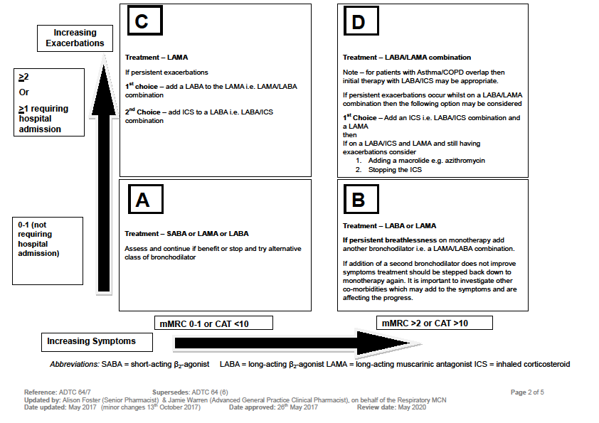

References
1. Global Initiative for Chronic Obstructive Lung Disease. Global strategy for Diagnosis, Management and Prevention of Chronic Obstructive Pulmonary disease. Report 2017. Available online at http://www.goldcopd.org. Accessed 06/05/2017
2. Fletcher CM. Standardised questionnaire on respiratory symptoms: a statement prepared and approved by the MRC committee on the Aetiology of Chronic Bronchitis (MRC Breathlessness score). BMJ 1960; 2: 1662. Available online at https://www.mrc.ac.uk/research/facilities-and-resources-for-researchers/mrc-scales/mrc-dyspnoea-scale-mrc-breathlessness-scale/ Accessed 06/05/2017.
3. COPD Assessment Test (CAT). Last updated October 2016. Available online at http://www.catestonline.org/.Accessed 06/05/2017
4. Thoracic Society guideline. Wedzicha JA, Miravitlles M, Hurst JR, et al. European Respiratory Journal 2017 49: 1600791; http://erj.ersjournals.com/content/49/3/1600791 Accessed 06/05/2017
Reference: ADTC 64/7 Supersedes: ADTC 64 (6) Page 5 of 5 Updated by: Alison Foster (Senior Pharmacist) & Jamie Warren (Advanced General Practice Clinical Pharmacist), on behalf of the Respiratory MCN Date updated: May 2017 (minor changes 13th October 2017) Date approved: 26th May 2017 Review date: May 2020

